Abstract title (Arial 12, bold)
Main Author (ej. M. González Pérez),ª author 2 (ej. J. M. López),^{b} author XXX.^{c} (Arial 11)
ªAffiliation1 (Dept., Faculty, Univ./Company, City), ^{b}Affiliation2, ^{c}Affiliation3. (Arial 9, ^{a b c…}for different institutions)
e-mail: mainauthor@university.es (Arial 9)

Keywords: abstract, table, figure. (maximum 3, Arial 10, italics)

Body text typed in Arial 11, with 14pts line spacing.
The abstract, including text, figures, tables and references must fit in one page and be written in English. Please do not modify margins.
Once finished, you must name the final file as "apellidos_nombre_University acronym (UAM, UCM or USC).pdf" and send it to dgfresna@ucm.es (UCM students), upload it to the corresponding task of the virtual classroom “Actividades formativas tutorizadas” (USC students) or upload it in the corresponding Moodle file (UAM students) in pdf format, before May 29th, 2024. Tables or Figures may be included in the Abstract if desired. Examples of Tables (Table 1) and Figures (Figure 1) are given below. References in the text should be included like this.¹
Table 1. Example of Table heading collecting the main results of this research work.¹ (Arial 9, single paragraph, 6 pts above/below the paragraph)
Column 1 | Column 2 | Column 3 | Column 4 | Column 5 | Column 6 | Column 7²
Single | paragraph | 2 pts³ | above | and | below | paragraph
Use | as many | rows | and | columns | as | you need
Tables | should | be | as | concise | as | possible
¹ Table footnotes may be required to complete any additional information. ² Table footnotes may be used in the Table heading or in any of the Table cells. (Arial 8, single paragraph, 6 pts above/below the paragraph). ³ Pts stands for points.
Underlined text in this template must be retained. (Text formatting indications in brackets must be deleted).²
No blank paragraphs (pilcrowmark, ¶) should be left above or below any Tables or Figures in the Abstract. Preparing the abstract is straightforward, just follow our instructions and type the abstract of your poster communication by overwriting the text in each section of this template and/or by adding Tables/Figures.³
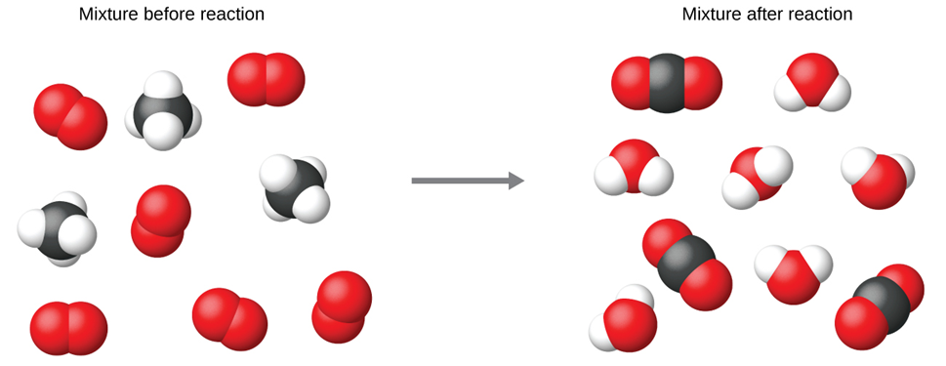
Figure 1. Example of Figure showing the mixture before reaction (left) and after reaction (right). (Arial 9, single paragraph, 6 pts above/below the paragraph)
References: (Arial 9, with 12 pts line spacing) (Please do not insert references with the automatic tool nor in the footer)
[1] (a) Luca, D.; Gail, J. L. Angew. Chem. Int. Ed. 2019, 37, 258. (b) Ben, Z.; Hanen, S. Chem. Rev. 2017, 99, 3181.
[2] (a) Shang, M.; Ren, M.; Zhou, C. Chem. Res. Toxicol. 2022. DOI: 10.1021/acs.chemx.9c0354 (to be used in case of just accepted articles) (b) Gatan, S. P. (2019). Immunization testing system (U.S. Patent No. 10,788,482).
[3] (a) Frank, J. Science and Engineering; MIT Press, 2018. (b) Ham, K. Crystal Lattices. In The Fundamentals of Crystallography, 3rd ed.; International Books on Crystallography, Vol. 2; Ongoing University Press, 2015; pp 87−134.
(Only one blank paragraph [pilcrow symbol] must be left below the References section)

